Apply filters to SQL queries
Project description
My organization is working to strengthen its system security. Part of my role is to review system activity, investigate potential issues, and identify which employee machines need updates. The steps below show how I used SQL filters to complete these security-related tasks.
Retrieving after hours failed login attempts
There was a possible security incident that occurred after business hours (after 18:00). All failed login attempts during that time need to be reviewed.
The following code shows how I filtered for failed login attempts that happened after 18:00:
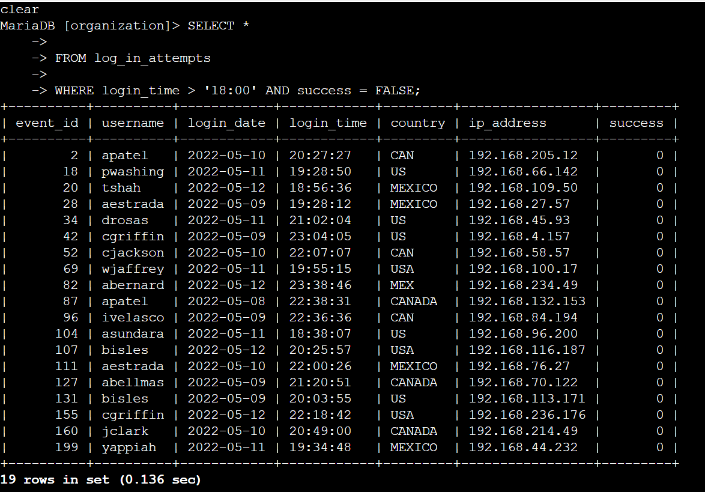
The first part of the screenshot is my query, and the second part is a portion of my output:
This query filters for login attempts that happened after 18:00 and were unsuccessful. I selected all data from the log_in_attempts table and then added a WHERE clause with an AND operator. The first condition (login_time > '18:00') filters for attempts made after business hours, and the second condition (success = FALSE) filters for the failed attempts. There are 19 failed login attempts that occurred after 18:00.
Retrieve login attempts on specific dates
A suspicious event happened on 2022-05-09. I needed to review all login attempts that occurred on that day or the day before.
Here is the query I used:
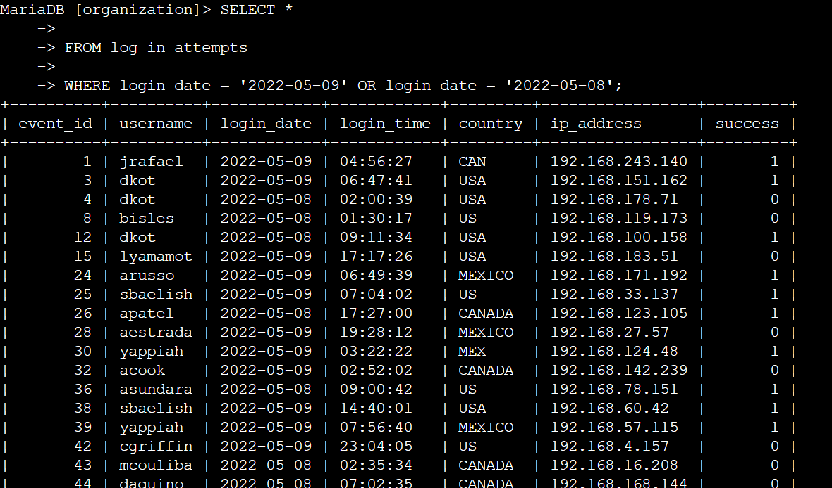
This query returns login attempts from either 2022-05-09 or 2022-05-08. I selected all data from log_in_attempts and used a WHERE clause with an OR operator. The first condition filters for attempts on May 9th, and the second condition filters for attempts on May 8th. Using OR ensures that both days are included. There are 75 login attempts in these two days.
Retrieve login attempts outside of Mexico
After reviewing the data, I noticed some login activity that occurred outside of Mexico. These attempts needed to be examined more closely.
To filter for login attempts that did not originate in Mexico, I used:
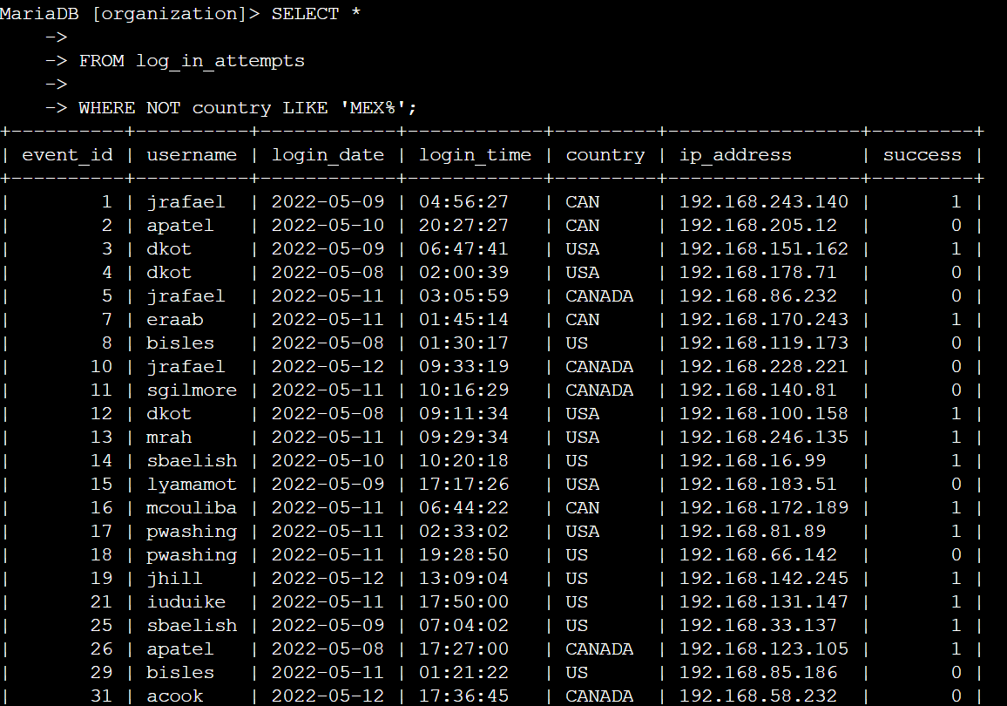
This query returns login attempts from any country other than Mexico. I selected all records from log_in_attempts and added a WHERE clause with NOT. The pattern MEX% matches both “MEX” and “MEXICO,” so using NOT LIKE 'MEX%' ensures that only attempts from outside Mexico are shown.
Retrieve employees in Marketing
My team needs to update devices used by employees working in the Marketing department in the East building.
Here is the query I used:
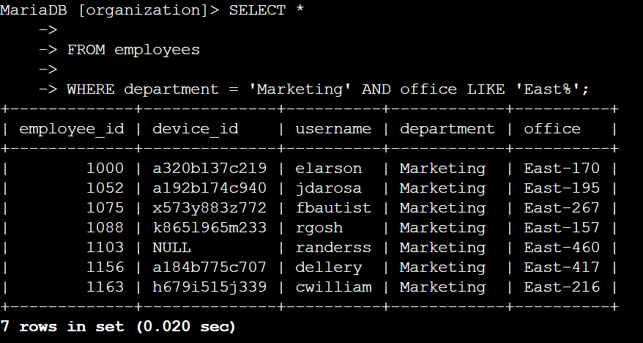
This query returns all Marketing employees who work in the East building. I selected all data from the employees’ table and used an AND operator to narrow the results. The first condition filters for the Marketing department, and the second condition matches any office starting with “East,” since the office names include both “East” and a specific room number.
Retrieving employees in Finance or Sales
Employees in the Finance and Sales departments need a different update, so I needed to identify all employees working in either department.
Here is the query I used:
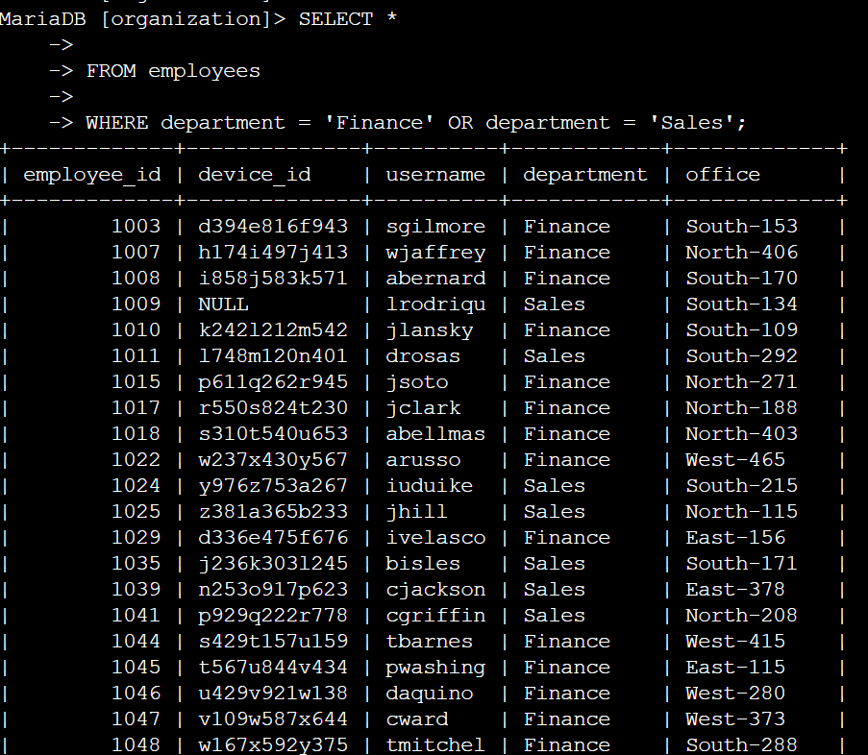
This query returns all employees who work in either the Finance or Sales departments. I selected all data from the employees’ table, then used OR to capture results from both departments. I used OR instead of AND because an employee only needs to match one of those two departments to appear in the results.
Retrieve all employees not in IT
Finally, my team needed to perform one more update for employees not in the Information Technology department.
Here is the query I used:
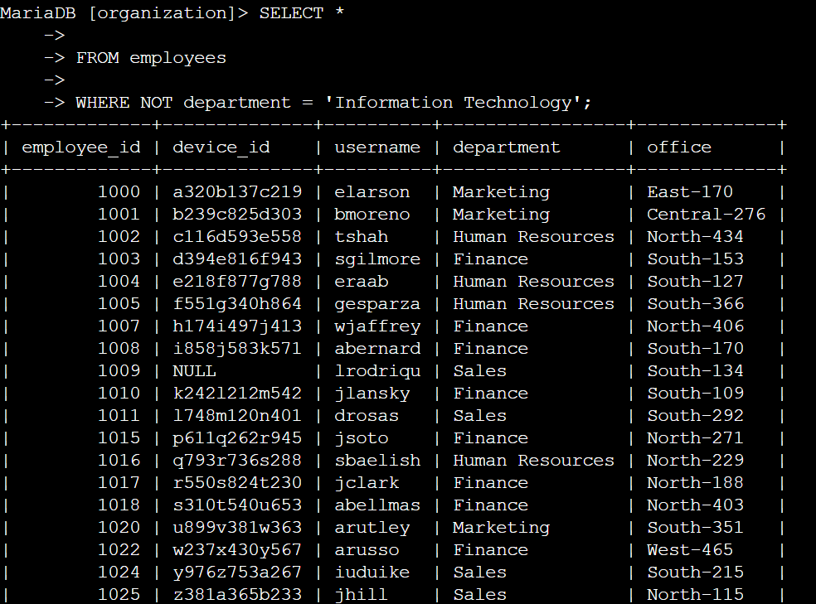
This query filters all employees who are not in the IT department. I selected all results from the employees table and added a NOT condition to exclude employees whose department is listed as “Information Technology.”
Summary
Throughout this activity, I applied SQL filters to identify important information in two tables: log_in_attempts and employees. I used the AND, OR, and NOT operators to narrow my results and LIKE with the % wildcard to match patterns in the data. These filters helped me investigate suspicious login activity and determine which employee systems needed updates.

